FINDING YOUR WAY AROUND THE BUILDINGS

PERRY LODGE

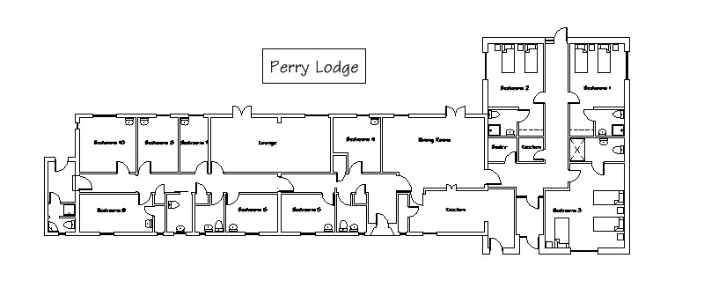

- DYFRDWY HOUSE

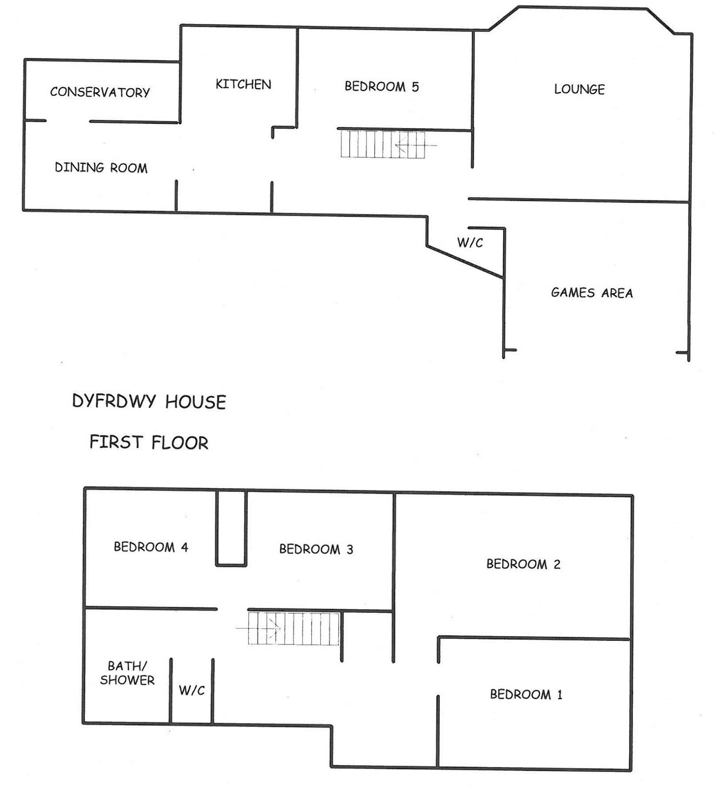

QUINTA HALL First floor -

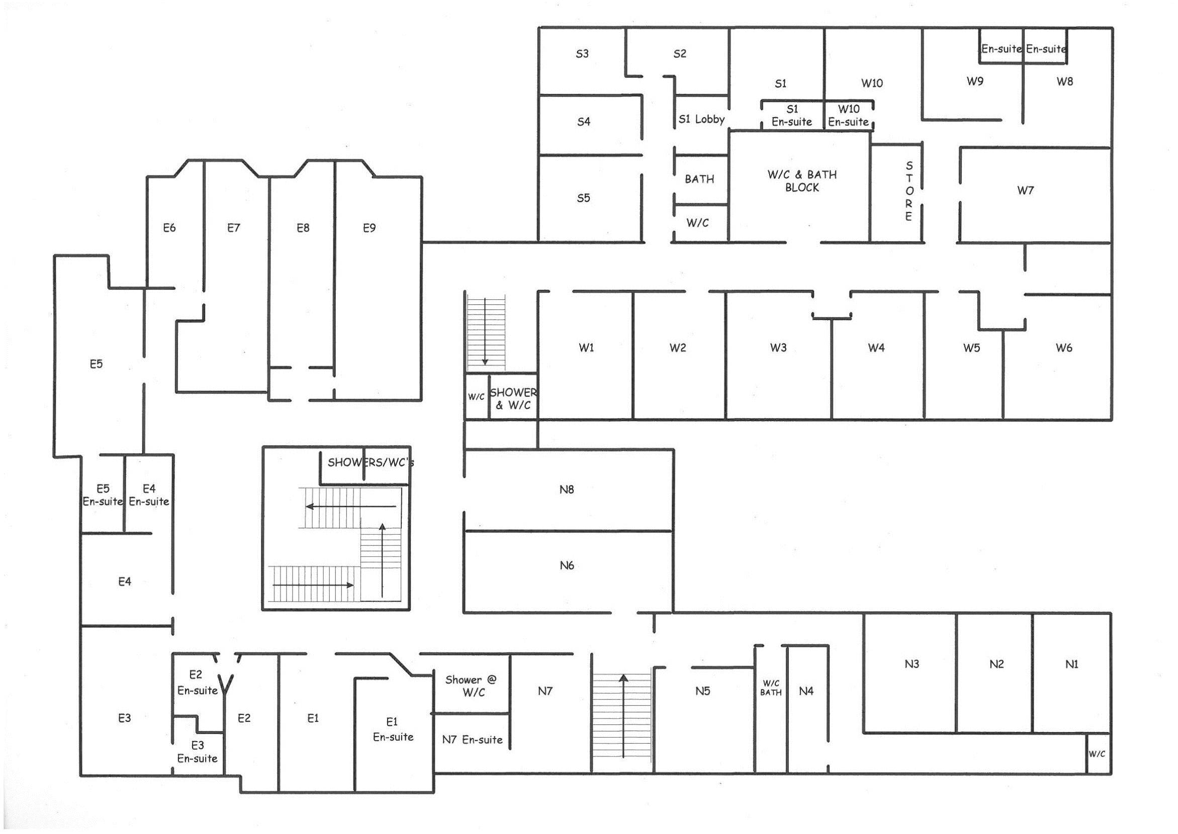

QUINTA HALL Ground floor -

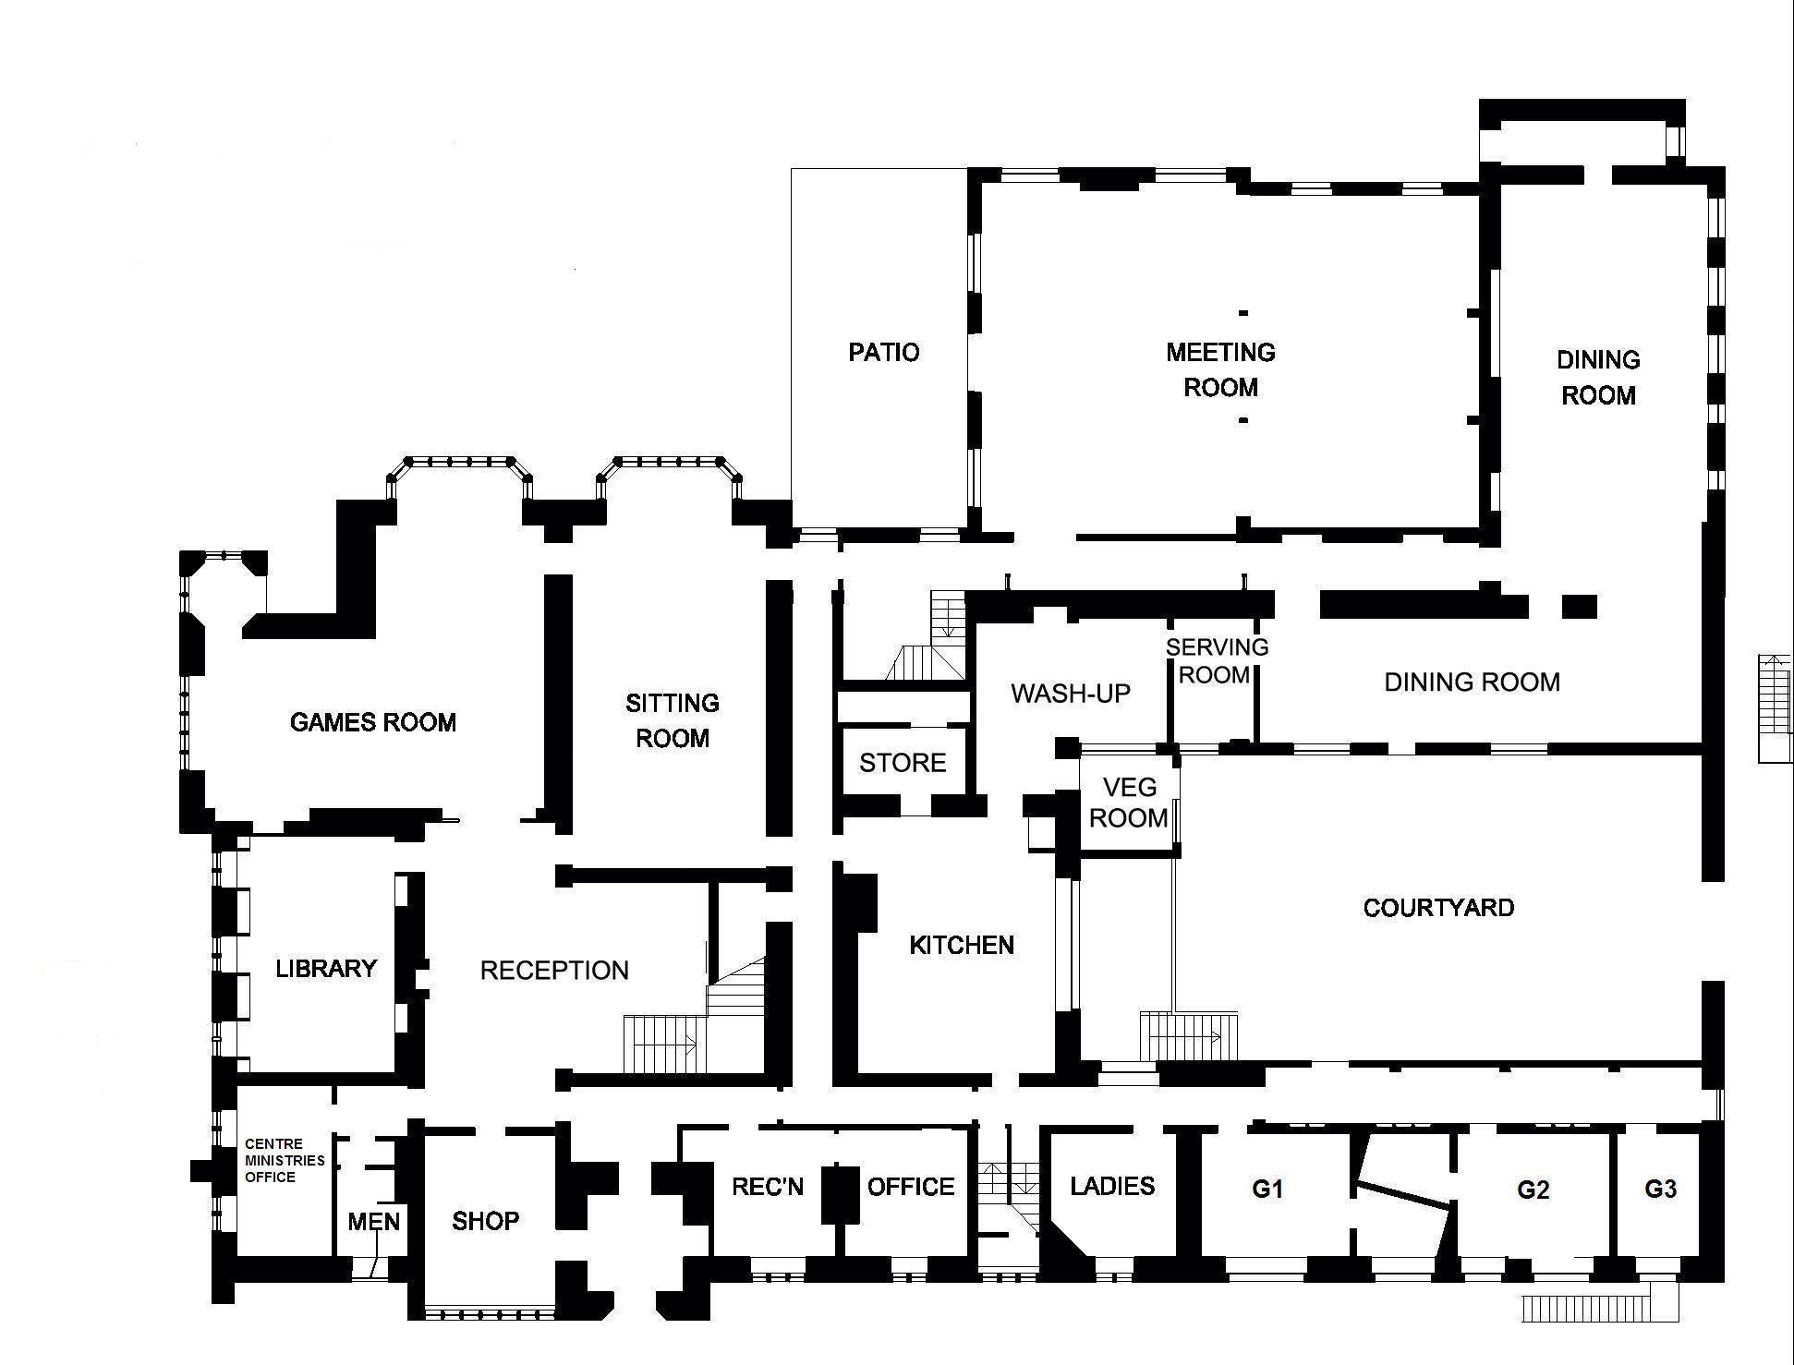

- SEVERN LODGE

First floor -
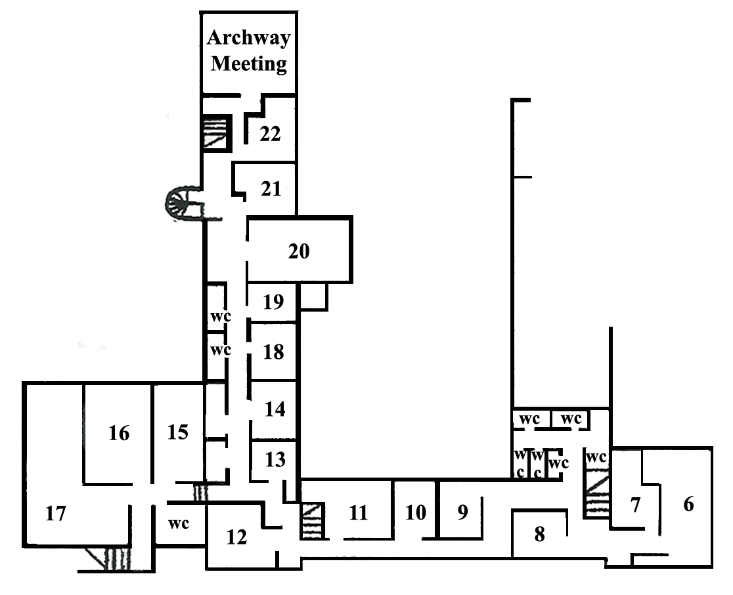

Ground floor -


